ABTALKS PARTICIPANT DEMO GUIDE · v3.1
Make a 2–4 minute demo of ABTalks: recruiter and candidate
Last checked: 9 Oct 2026, against www.abtalks.in. Screens can change; if something looks different, follow what the page says.

Your brief
Record a 2–4 minute screen video that shows ABTalks working from both sides: a recruiter looking for talent, and a student building proof of skill. This guide gets you into both sides and shows the main screens. It is a starting point, not a script to copy.
- Show both sides. Start from the website's landing page, sign up as a recruiter and as a candidate, and connect the two.
- Explore. There is more in the product than this guide covers. Click around and find the features you find most interesting.
- Be creative. Your angle, story, voice-over and editing are yours. Two demos that look the same are a missed chance.
- Keep it tight. 2 minutes minimum, 4 minutes maximum. Cut anything that does not help the story.

Tip: you need two logins at once. Use two Chrome profiles (or one normal window and one Incognito window): one for the recruiter, one for the candidate. Then you can switch between them on camera without signing out.

Setup: Get a temporary email (applicable only if you have not registered with an Organization Mail ID)
A temporary email inbox works, and you can use one for the candidate account too.
Step 1. Open https://temp-mail.org and copy your address
A temporary address is created for you as soon as the page loads. Click Copy. Keep this tab open: the 6-digit code will arrive here. Click Refresh if it does not show up straight away.
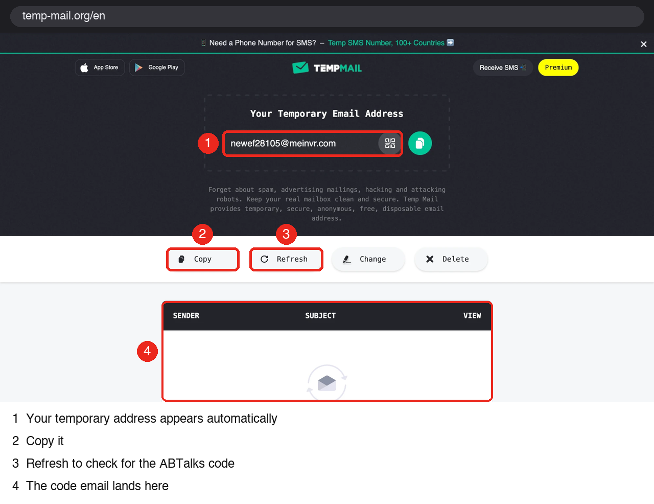
Figure 1 — temp-mail.org: copy the address, refresh for the code
Heads up: temporary inboxes are not private and expire. Use them only for this demo, never for anything real. If the tab closes you may lose the address, so finish sign-up in one go.

Part A — Recruiter onboarding
Step 2. Start from the landing page
Open https://www.abtalks.in. Click Get Started (top right), then Recruiter. (Post a requirement leads to the recruiter side too.) Starting here shows the full journey a real recruiter takes.
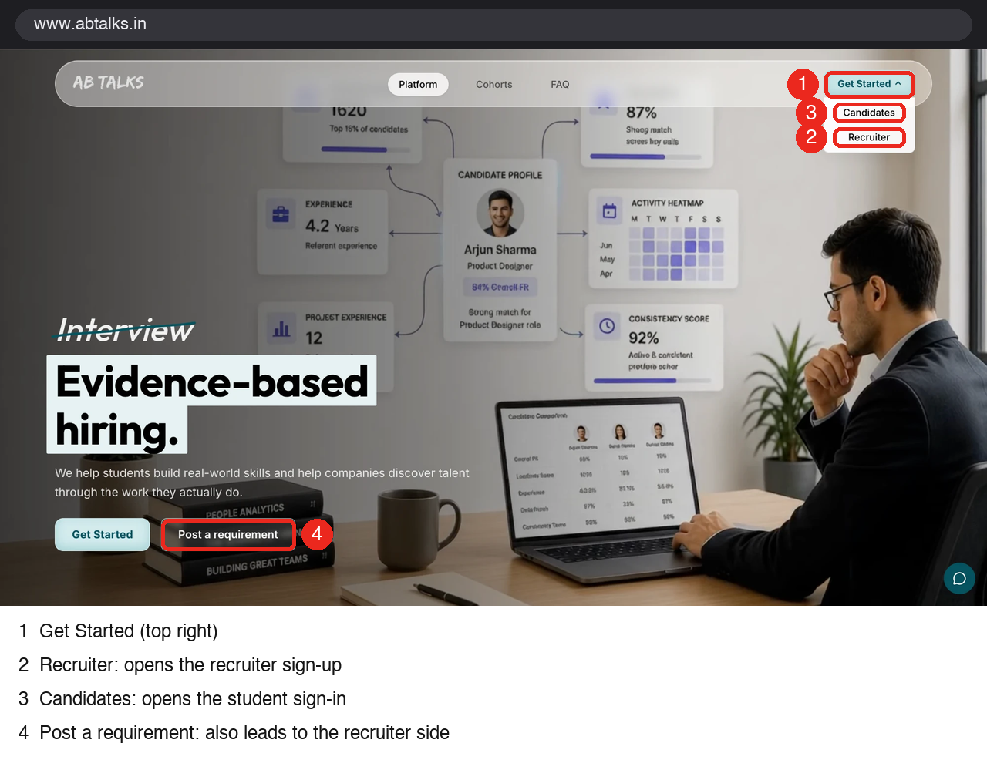
Figure 2 — Landing page: Get Started, then Recruiter
Step 3. Set up your workspace
You reach “Let's build your recruiting workspace”. It takes about two minutes, has three steps (You, Company, Verify) and needs no password. Click Set up workspace. If you already registered, click Sign in instead.
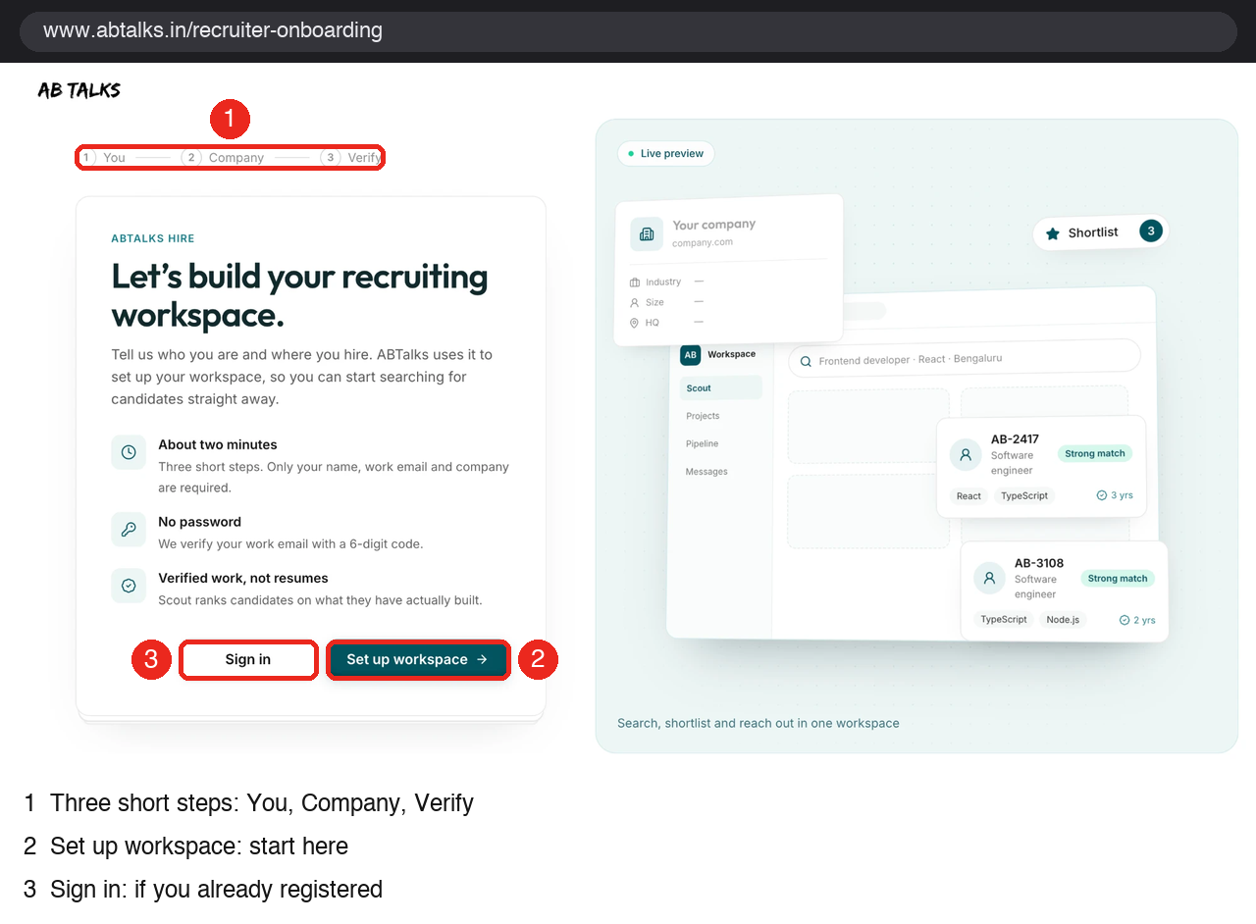
Figure 3 — Recruiter onboarding start
Step 4. Step 1 of 3 — You
Enter your full name and paste your temp-mail address as the work email. Click Continue. The live preview on the right shows how you will appear to candidates.
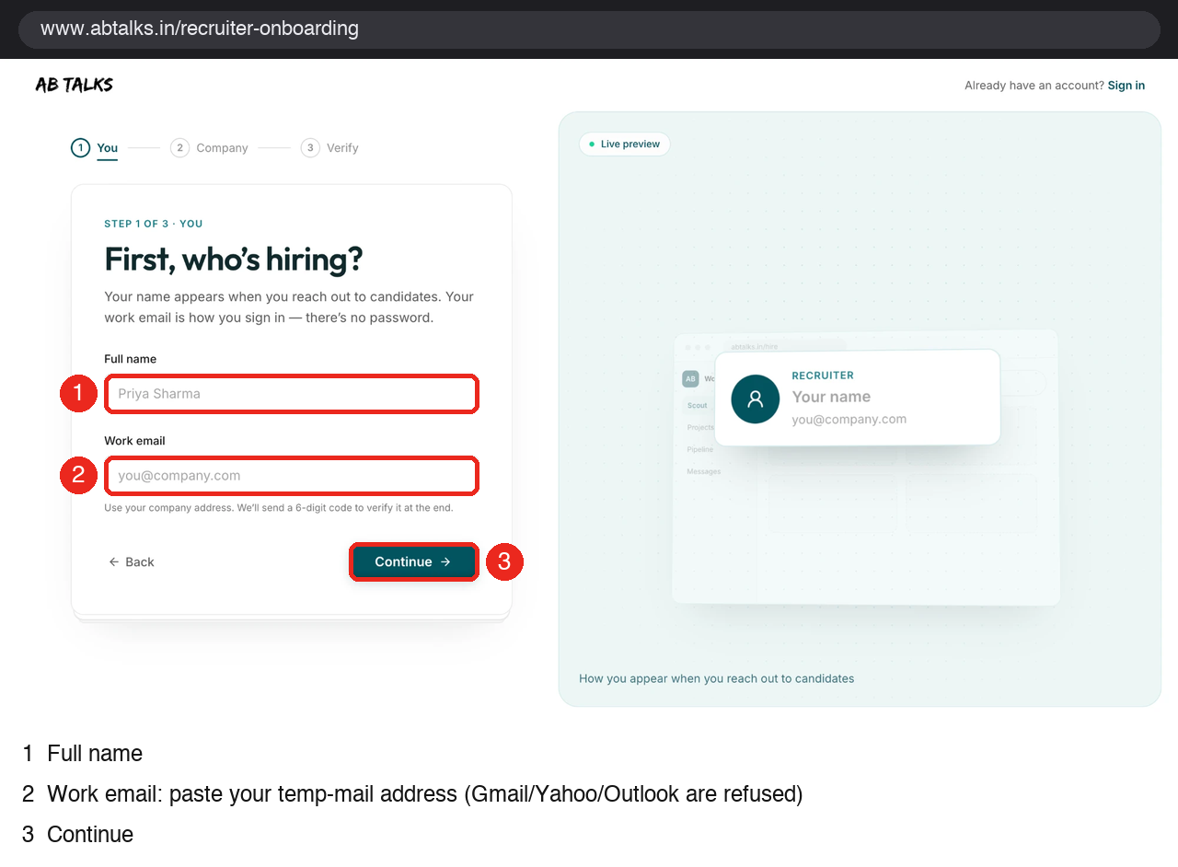
Figure 4 — Step 1: name and work email
Step 5. Step 2 of 3 — Company
Only the company name is required. Website, industry, company size and headquarters are optional but make the company card look real in your video. Click Continue.
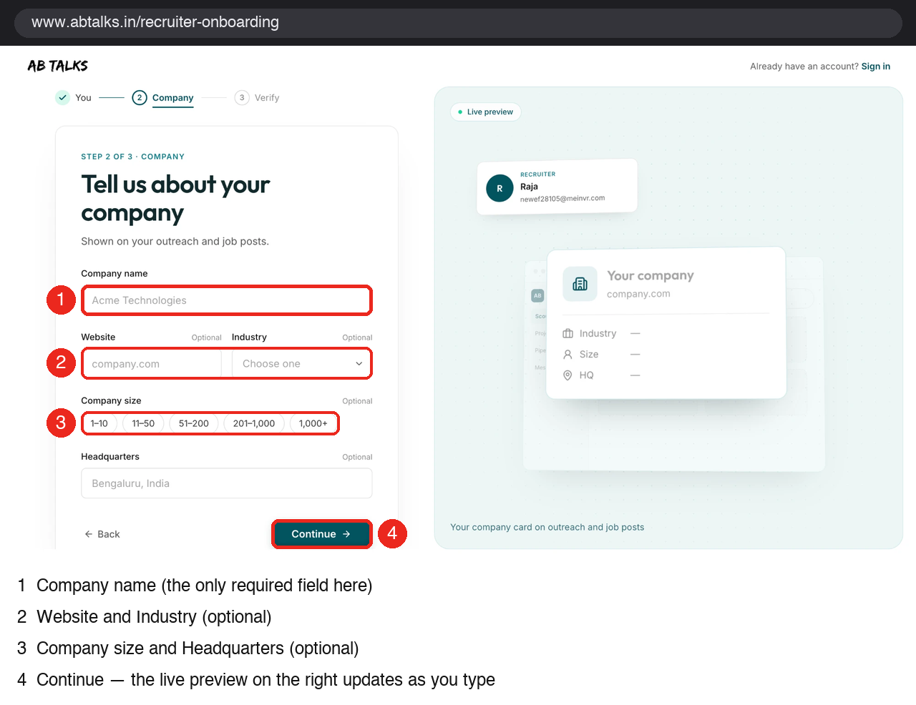
Figure 5 — Step 2: company details
Step 6. Step 3 of 3 — Verify
Check your details (use the pencil icons to fix anything), tick Terms of Service and Privacy Policy, and click Send code. Go to your temp-mail tab, refresh, open the ABTalks email and enter the 6-digit code. The code expires after 10 minutes.
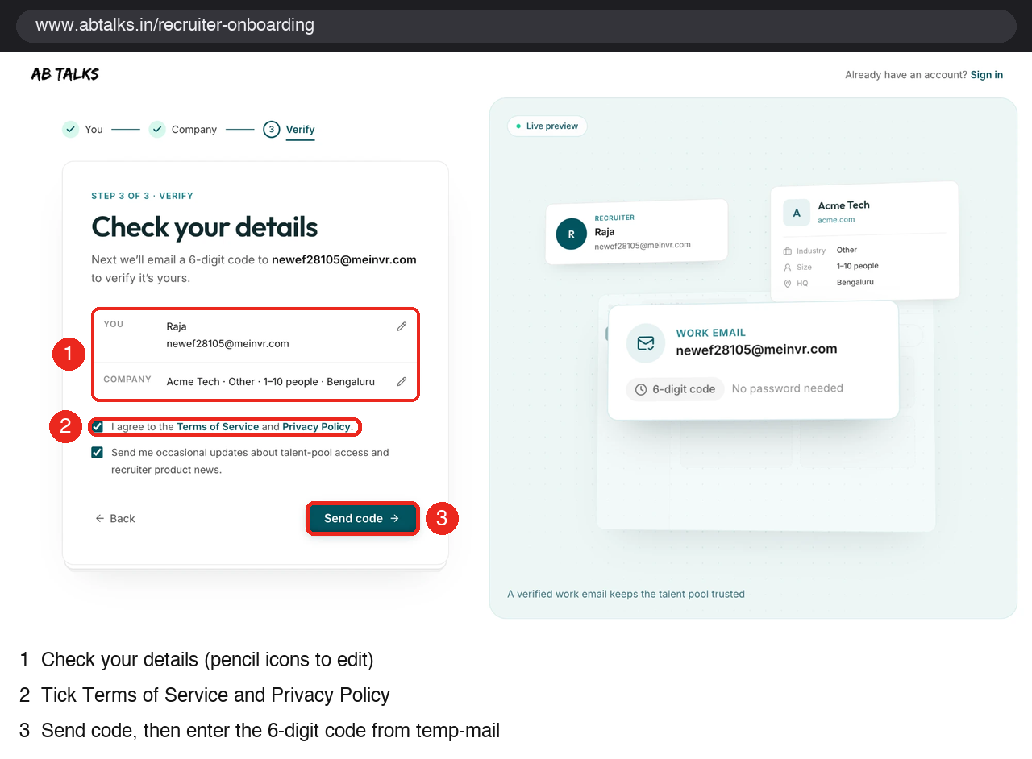
Figure 6 — Step 3: check details and send the code
Step 7. You are in: the Scout home screen
Your workspace opens straight away. The home screen asks “Who are you looking for?”. Type a brief in plain English and press Search. Mention a location, years of experience, a role, an education qualification and skills for better matches. Example: “AI Engineer in Delhi with 4+ years of experience in Agentic AI”.
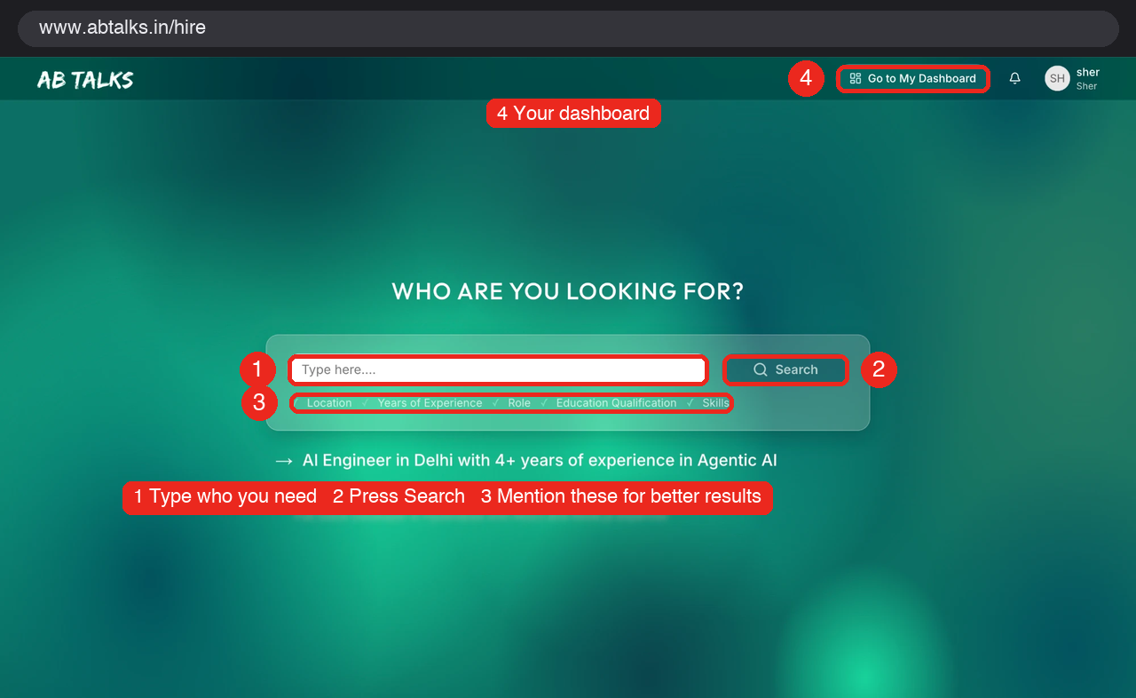
Figure 7 — Recruiter home (Scout): type a brief, press Search
Step 8. Understand the credit system
Open Credits from the top-right pill. Every recruiter starts on the Free plan with $200.00 of credits (one credit is one dollar).
Action | Cost
Search and assessments | Free
Unlock a candidate's contact details | $0.50 each
Re-open a candidate you already unlocked | Free
Starting balance | $200.00 (covers about 400 unlocks)
For more credits | Email team@abtalks.in

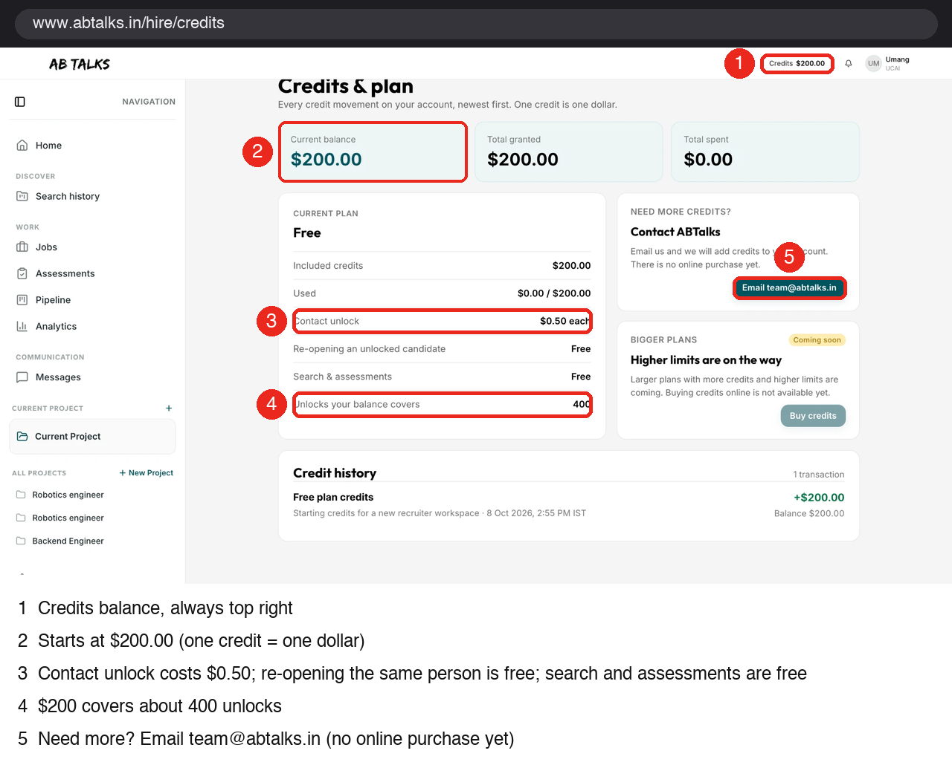
Figure 8 — Credits & plan, with credit history
Every credit movement shows in Credit history, newest first. A great demo moment: unlock one candidate, then show the balance drop by $0.50 and the new line in the history.
Step 9. Work the hiring tools
Everything a recruiter needs is in the left menu. Projects keep your searches together, so you can come back to them.
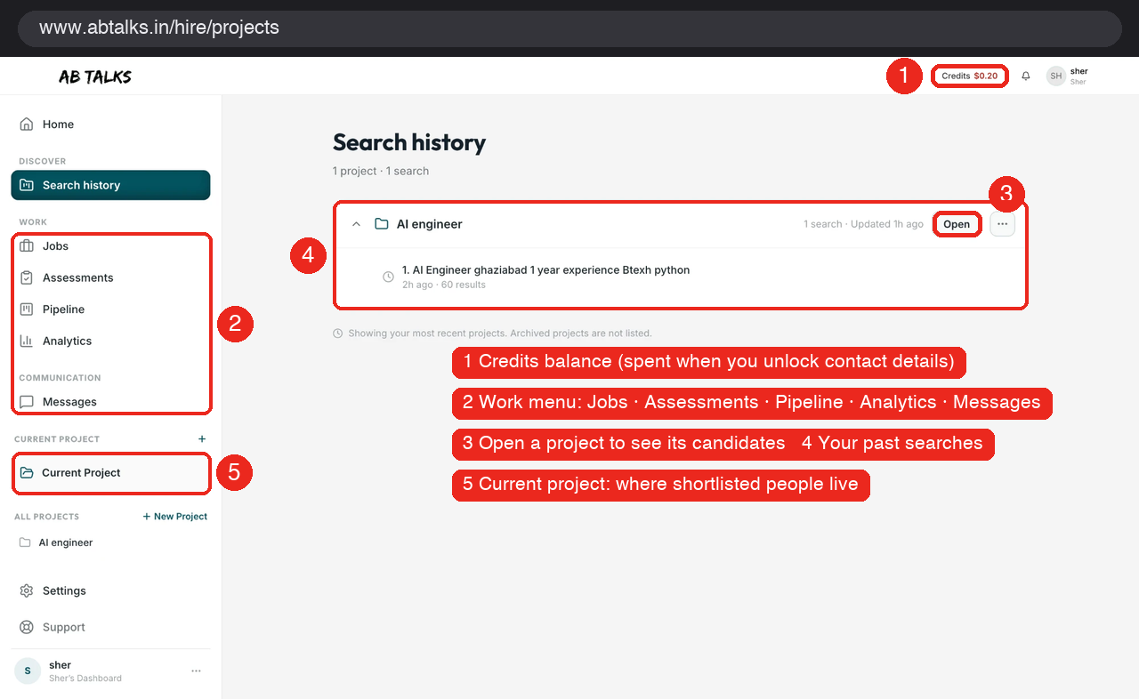
Figure 9 — Search history, work menu and credits
- Search history / projects: every search is saved in a project with its result count. Open one to see its candidates.
- Candidate profile and unlock: click a candidate to read their profile beside the results. Contact details stay hidden until you unlock; the dialog shows the cost before you confirm.
- Pipeline: move people through stages (Sourced, Shortlisted, Contacted, Screening, Interviewing, Offer, Hired, Rejected, Withdrawn). Stages stay put after a refresh.
- Assessments: build a test (sections, single choice, multiple choice, written answer, file upload, duration, pass mark), assign it, and see who started, finished and scored.
- Jobs: post a job and control when it goes live and closes. Applicants join your pipeline.
- Messages: email a candidate from inside ABTalks; replies come back to you.
- Analytics: your own searches, views, shortlists, unlocks and outreach.

Part B — Candidate side
Step 10. Sign up as a candidate
In your second browser profile, open https://www.abtalks.in, click Get Started, then Candidates. Sign in with Google, or choose Email code and use a temp-mail address (tick Terms, then enter the 6-digit code). A new email creates a new account.
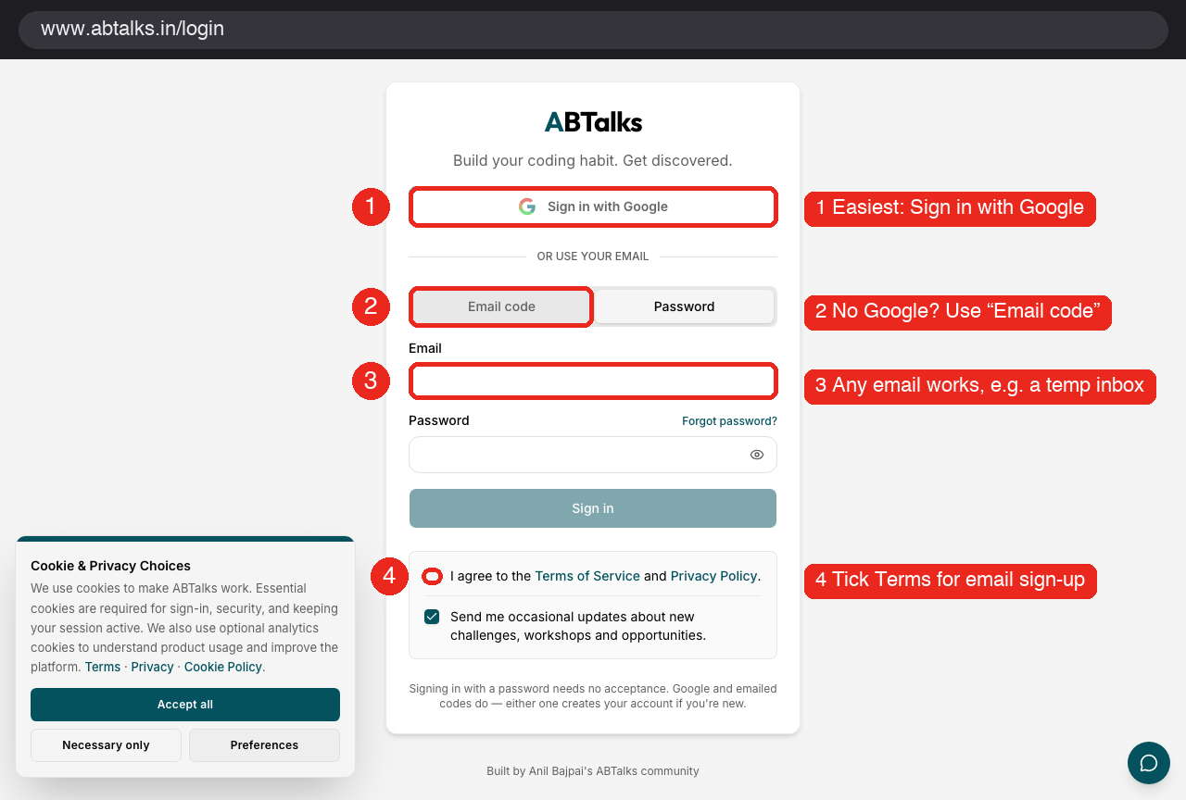
Figure 10 — Candidate sign-in: Google or email code
Step 11. Tour the dashboard
The dashboard shows the student journey: Complete profile, Build skills (60 days of daily tasks), Test skills, Get hired. Below it are your learning tracks, your 60-day activity squares and your streak.
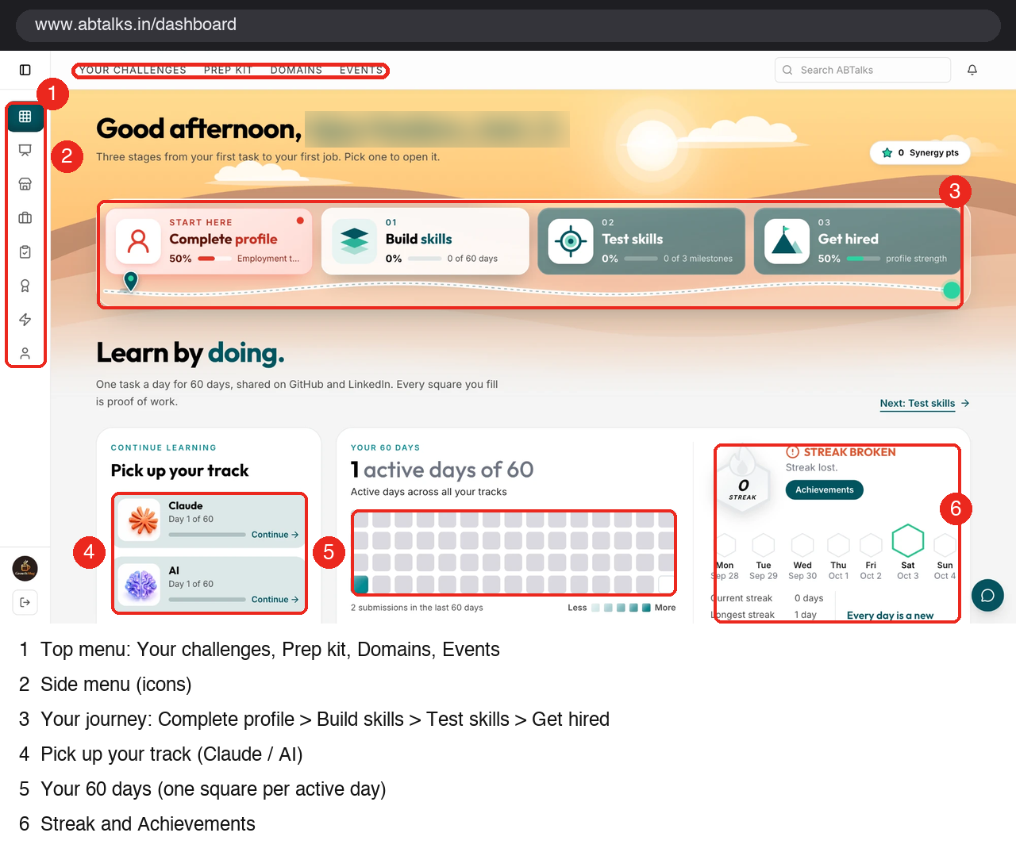
Figure 11 — Candidate dashboard
Step 12. Use the side menu to explore
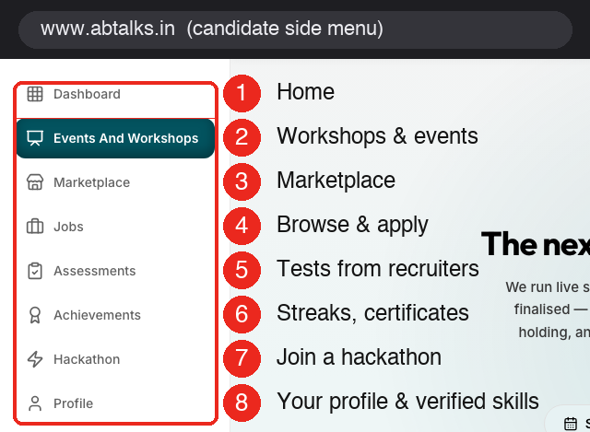
Figure 12 — Candidate side menu
- Profile and verified credentials: the page recruiters judge. Skills earned by finishing a track show as “Verified by ABTalks”; skills typed by hand show as claimed. Certificates can be checked by anyone at abtalks.in/verify/ plus the certificate ID. Add skills, education and a project so recruiters can find you; there is no visibility switch.
- Assessments: tests a recruiter assigned to you. Answers save as you go. Fullscreen exits, tab switches and copy/paste are recorded.
- Events And Workshops: live sessions most Saturdays, with a calendar, upcoming and past sessions. Register per session.
- Hackathon: the current event and how to register. After registering you get “Your desk” with the brief and submission form.
- Marketplace: spend Synergy points. You earn points from daily task submissions and referrals; your balance shows on the dashboard.
- Achievements: streaks, badges and certificates.
- Jobs: browse, filter and apply once per job, then track what happened.
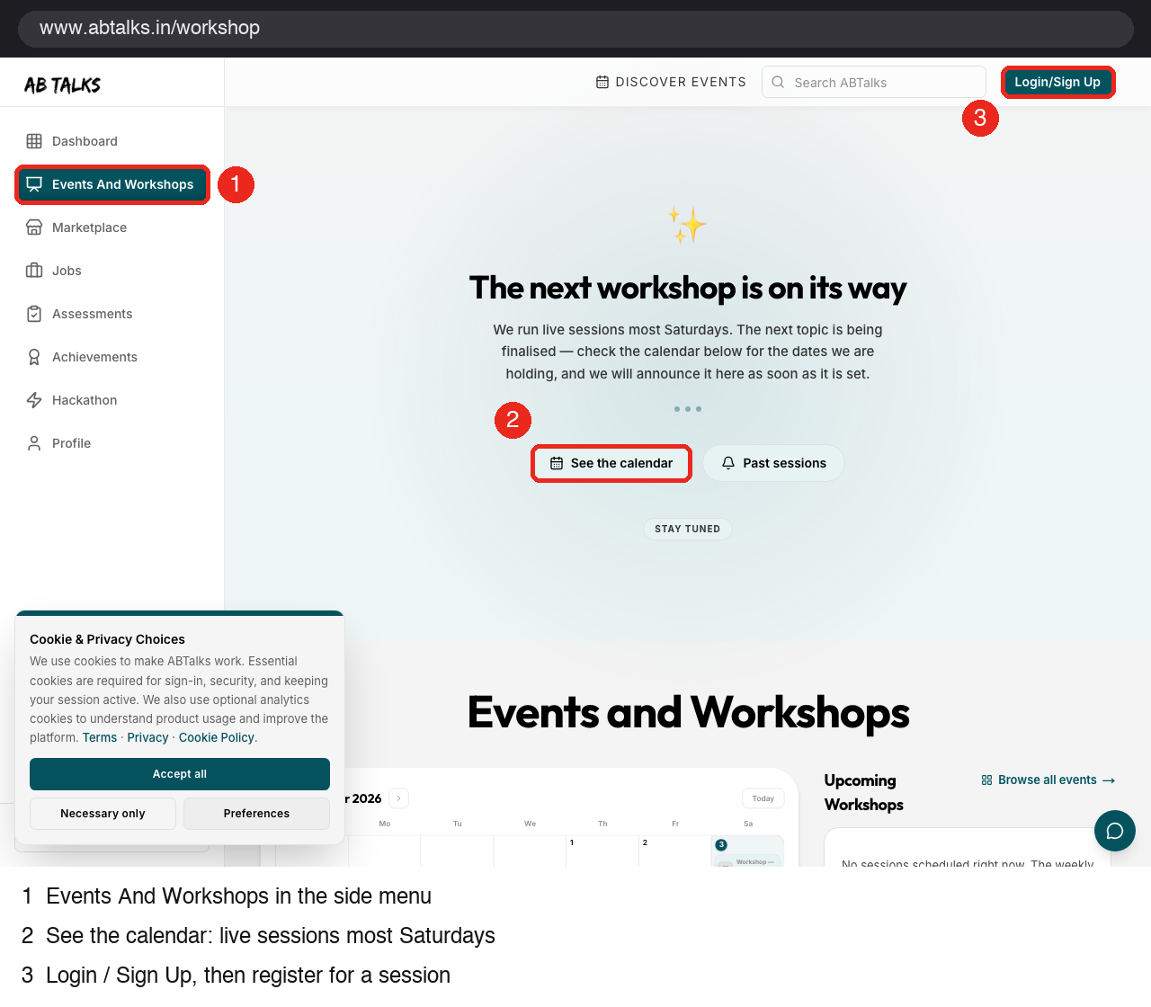
Figure 13 — Events and Workshops
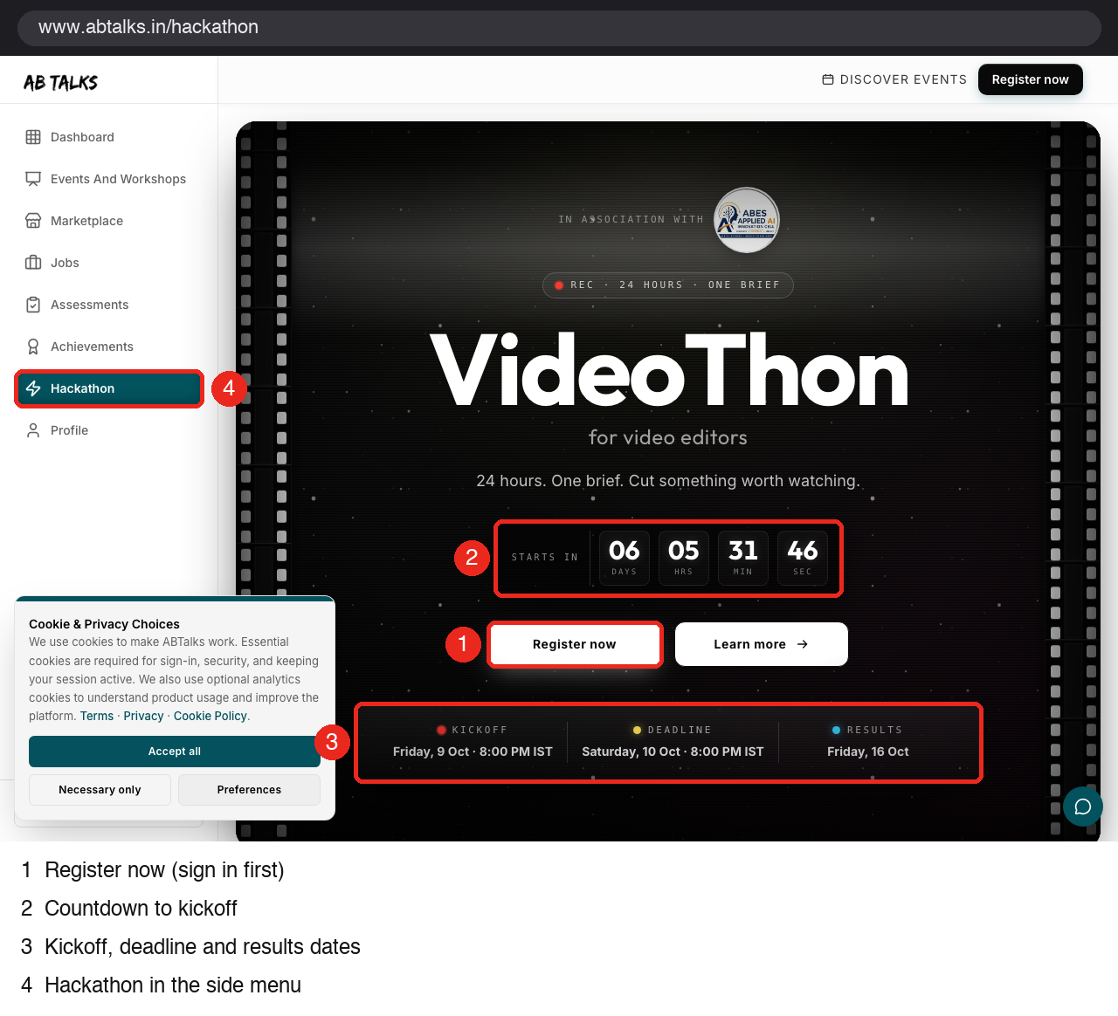
Figure 14 — Hackathon page
Step 13. Try the AI features
- AI mock interviews: spoken, not typed. An AI interviewer asks about what you know, follows up on your answers and gives a report that cites what you said. About 15 minutes, 7 questions. Free with any ABTalks account. (abtalks.in/mock-interviews)
- Help chatbot: the round chat bubble at the bottom right of every page. It answers questions about ABTalks from approved ABTalks information only, and points to support when it doesn't know. Try asking it something on camera.
- Learn: free in-depth courses, such as Agentic AI Systems.
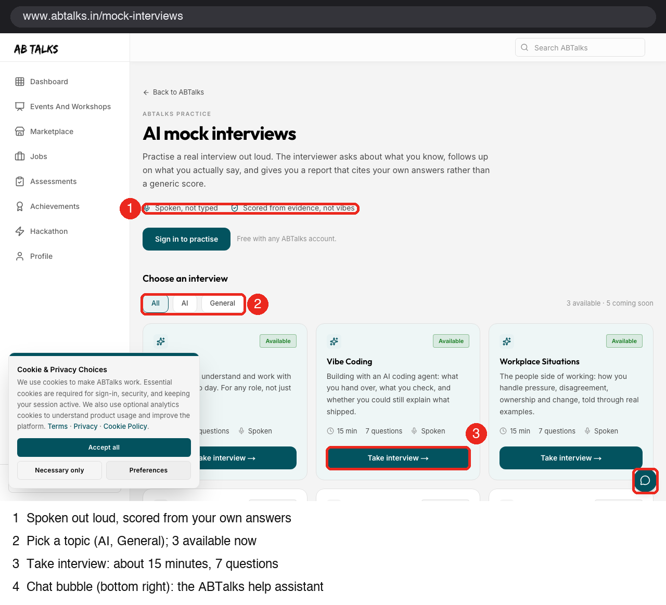
Figure 15 — AI mock interviews and the chat bubble

Part C — Explore beyond this guide
This guide does not cover everything. Use this checklist to discover more, and feature what impresses you most. You are not expected to show all of it in 4 minutes.
Feature | Where to find it | Demo idea
Help chatbot | Chat bubble, bottom right | Ask it a real question a new student would have
AI mock interview | Candidate menu or /mock-interviews | Show 20 seconds of the spoken interview and the report
Marketplace and Synergy points | Candidate side menu | Show what effort can be redeemed for
Verified skills and certificates | Candidate Profile; /verify/<id> | Contrast “verified” with “claimed” skills
Recruiter view of a profile | Candidate Profile | Show exactly what a recruiter sees
Learn courses | /learn | Open a module and show it is free
Prep kit, Domains, Events | Candidate top menu | Pick one and explain who it helps
Search ABTalks | Search bar at the top | Find a feature or event fast
Live preview during onboarding | Recruiter sign-up, right panel | Show the company card building as you type
Credit history | Recruiter Credits page | Unlock once and show the $0.50 entry
Assessments loop | Recruiter Assessments, then candidate Assessments | Recruiter assigns a test, candidate takes it
Notifications | Bell icon on both sides | Show what each side is told

Part D — Plan your edit (Feel free to use your creativity)
Time | Scene | What to show
0:00–0:20 | Hook | The problem in one line, and the landing page
0:20–1:20 | The student | Candidate sign-up, dashboard, a daily task, profile with verified skills; one AI feature (mock interview or chatbot)
1:20–2:30 | The recruiter | Get Started, Recruiter, 3-step onboarding with temp mail, Scout search, a candidate profile
2:30–3:20 | The connection | Unlock contact details ($0.50, balance drops), add to pipeline, assign a test or send a message
3:20–4:00 | Your twist | The feature you found most interesting, and a closing line

For a 2-minute cut, keep the hook, the recruiter search and the unlock moment, plus one candidate screen.

Recording tips
- Record at 1080p. Close other tabs, hide bookmarks and notifications, and use 100% browser zoom. You might even choose to explain the demo using voice audio.
- Do the sign-ups once before recording, so the video is not mostly waiting for codes. You can show sign-up quickly, then cut.
- Use fictional names and companies. Never show real personal data, passwords or real email inboxes.

Troubleshooting
What you see | What to do
“Use your work email address…” | You entered a personal email (Gmail, Yahoo, Outlook and similar). Use a temp-mail address.
No code in temp-mail | Click Refresh and wait up to a minute. Then go back and send the code again. Still nothing? Generate a new temp address (Change) and start again.
Code rejected or expired | Codes last 10 minutes and work once. Request a new one.
Lost the temp-mail tab | That address may be gone. Make a new recruiter account with a new temp address.
Already registered | Use Sign in on the onboarding page (top right) with the same email.
Credits running low | Each unlock is $0.50 from a $200 start. If you run out, email team@abtalks.in.
Candidate not found in recruiter search | Add skills, education and a project to the candidate profile, then search with those skills.
Candidate Assessments page is empty | A test appears only after a recruiter assigns one to that candidate.

Rules
- If you have created account using temp-email use the account only for the demo.
- Don't enter anyone's real personal data, and don't contact real candidates.
- Unlock only what your story needs.

